**DAILY ONLINE ACTIVITIES SUMMARY**

|  |  |  |  |  |  |  |  |  |
| --- | --- | --- | --- | --- | --- | --- | --- | --- |
| **Date:** | 07-06-2020 | | | | | **Name:** | Anvitha H M | |
| **Sem & Sec** | 4th ‘A’ | | | | | **USN:** | 4AL18CS010 | |
| **Online Test Summary** | | | | | | | | |
| **Subject** | | N/A | | | | | | |
| **Max. Marks** | | N/A | | **Score** | | | N/A | |
| **Certification Course Summary** | | | | | | | | |
| **Course** | Introduction to digital marketing. | | | | | | | |
| **Certificate Provider** | | | Great learning academy | | **Duration** | | | 5.5 hours |
| **Coding Challenges** | | | | | | | | |
| **Problem Statement:**  Program in C++ to swap two numbers using Friend bridge. | | | | | | | | |
| **Status:** Executed | | | | | | | | |
| **Uploaded the report in Github** | | | | | YES | | | |
| **If yes Repository name** | | | | | <https://github.com/anvithahm/LOCKdown-coding> | | | |
| **Uploaded the report in slack** | | | | | Yes | | | |

**Online test:** N/A

**Certification course:**

Introduction to digital marketing

The course includes brief explanation on consumer journey of today, understanding brand purpose and detailed explanation of new medias for marketing.

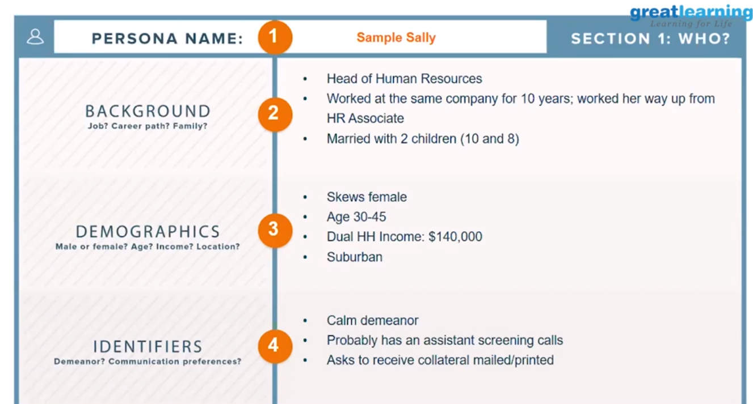

Online coding challenge

The programing statements of the day is “program in C++ to swap two numbers using Friend bridge”.

Solution: Executed and uploaded in Github repository.

Link: <https://github.com/alvas-education-foundation/Anvitha-H-M>

